WMEC111 Unity Game Task

Yanni Chen - 45753482

**Effects used in this assignment:**

* Terrain (25%)
* Primitives (25%)
* Textures + normal map (10%)
* Animation with trigger effect (10%)
* Lighting (5%)
* Particle effects (10%)

**Terrain**

* Terrain (25%)

For my terrain I created a simple stone field with small hills on the sides and a river running through the middle of the terrain.

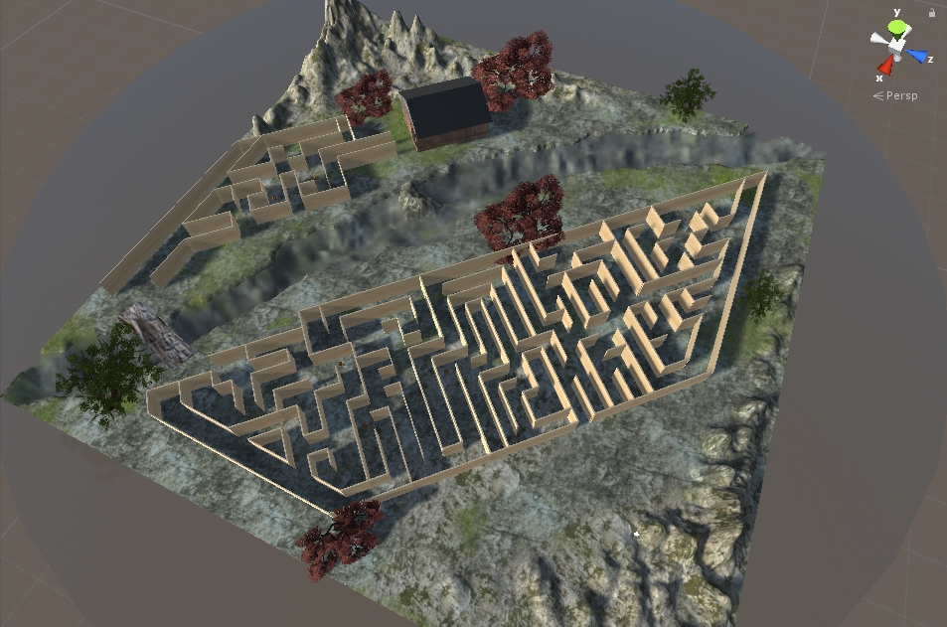

I also addd some trees and grass detail. WindZone is used to let the trees move.

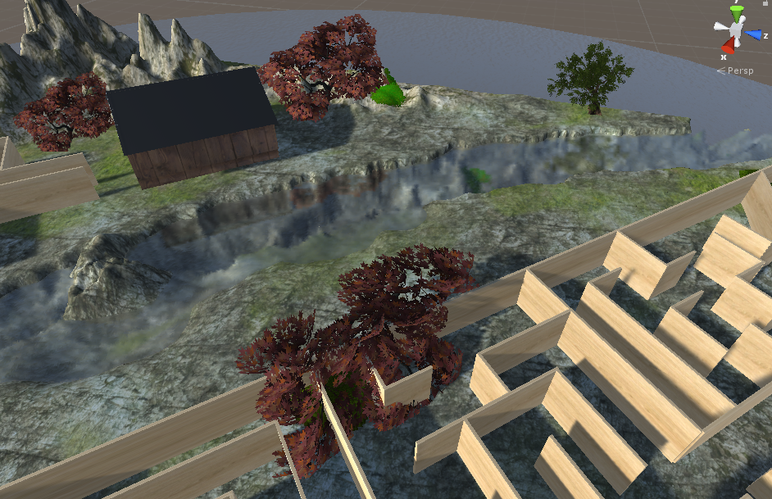

**Sun**

* Animation

The Sun is a directional light. Using animation rotates 360 degrees in 60 minutes to show the alternations of day and night.

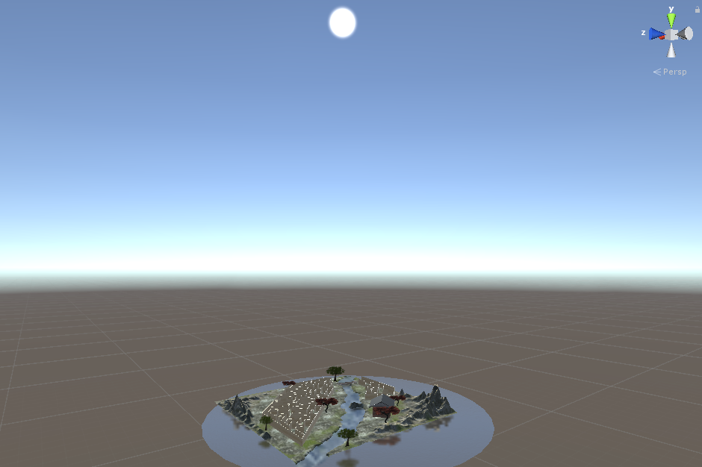

**Maze**

* Primitives (25%)
* Textures (5%)

I used nearly 200 cubes to make the maze and added texture of wood. The textures have normal maps to catch The sun.

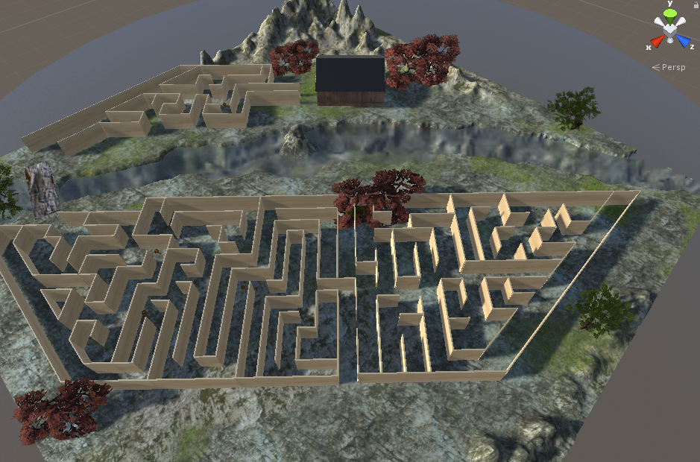

**Bridge**

- Primitives (25%)

* Textures (5%)

I made a bridge with Unity Primitives to let players cross the river and added texture of wood to make it become a wooden bridge.

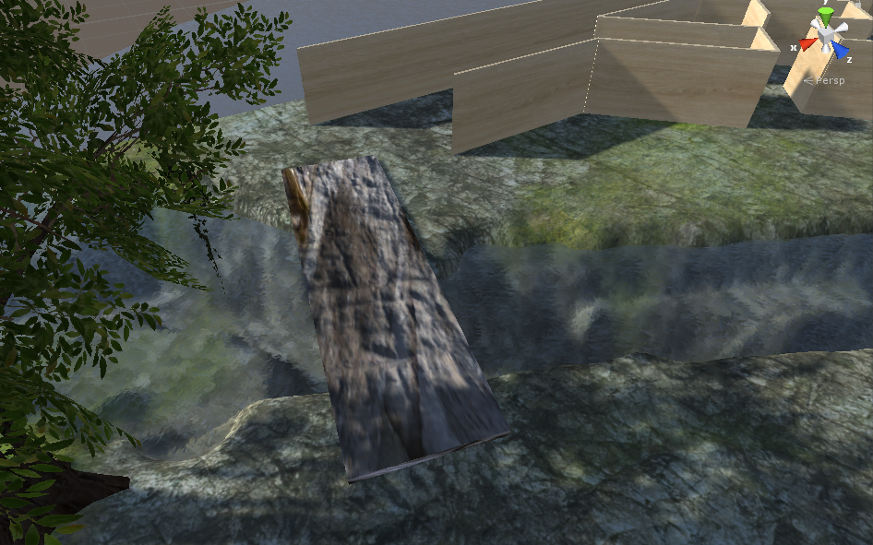

**House**

* Primitives (25%)
* Textures + normal map (10%)
* Particle effects (10%)
* Lighting (5%)
* Animation with trigger effect (10%)

I've made a house by unity Primitives and textured it with bricks and wood panelling.

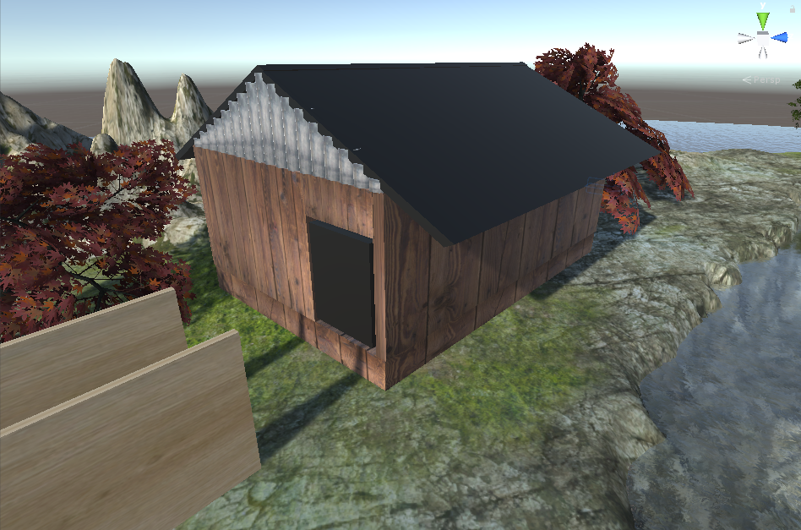

The door is made by a cube and adding a Hinge Joint, it will open when you touch it.

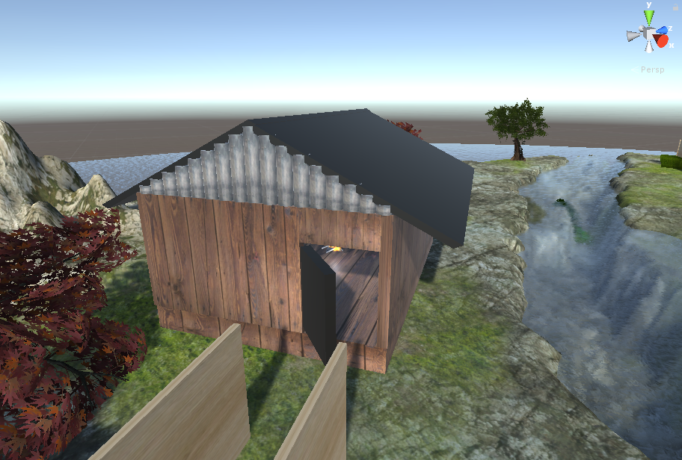

The inside of the house is the fire, using a particle system and light point, the house is static, so the inside of the house is the fire to illuminate the room.

